EXPERIMENT – 3(A)
PANDAS LIBRARY – DATA PREPROCESSING
Aim:
To understand the importance of data preprocessing in data science

Procedure:
1.Upload the given dataset(csv file) and read it
2. Import necessities such as numpy ,pandas
3. Now , process the data , find missing values and replace it with
mean(),mode(),median()
PROGRAM:
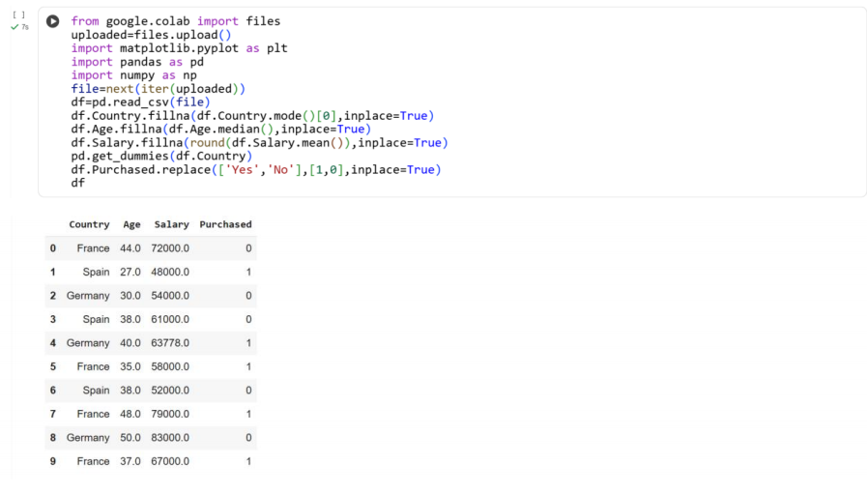
Result:
Thus the python program to find missed values and replacing it was executed and verified

EXPERIMENT – 3(B)
PANDAS LIBRARY – HANDLING MISSING VALUES
Aim:
To handle and analyze missing and inappropriate data in dataset

Procedure:
- Upload the csv file and read it
2.Import necessities such as pandas , numpy
3. Now check for missing and inappropriate data to replace with appropriate data
PROGRAM:
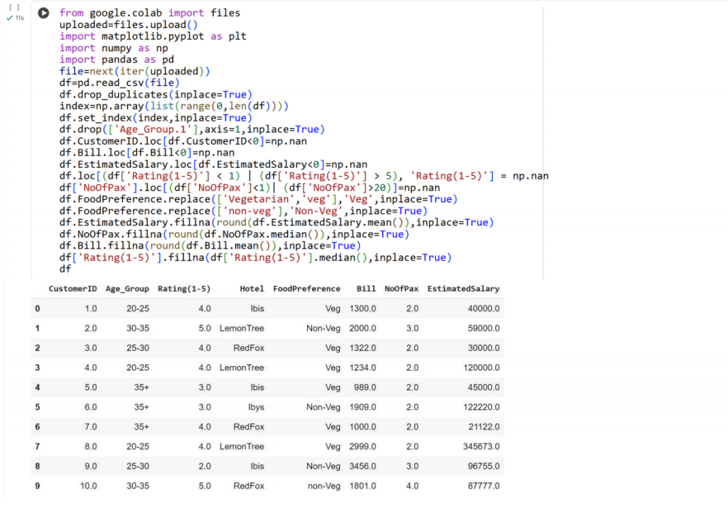
Result:
Thus we find missing and inappropriate data and replaced with appropriate ones

EXPERIMENT-3(C)
PANDAS LIBRARY – CREATE CSV FILE
Aim:
To create a dataset and make it as csv file and handle inappropriate values

Procedure:
1.Create a dataset
2. Import pandas and numpy and with its help, create data frame and change it to csv file
3. Read the dataset and handle inappropriate and missing values
Program:
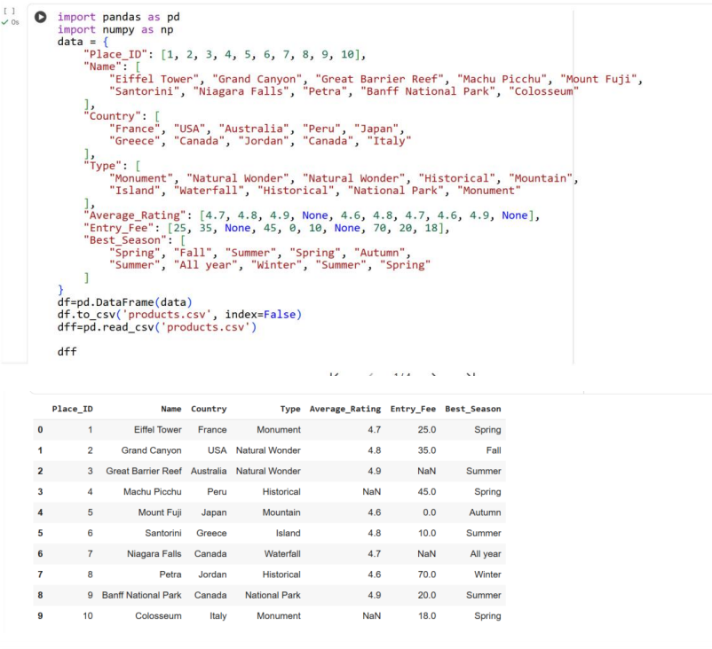
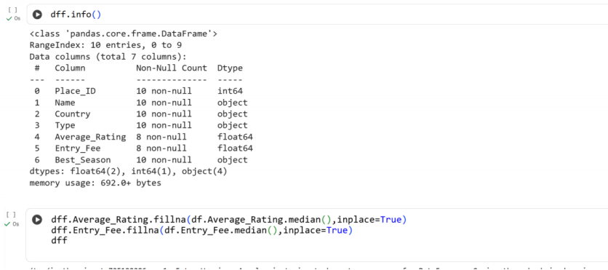
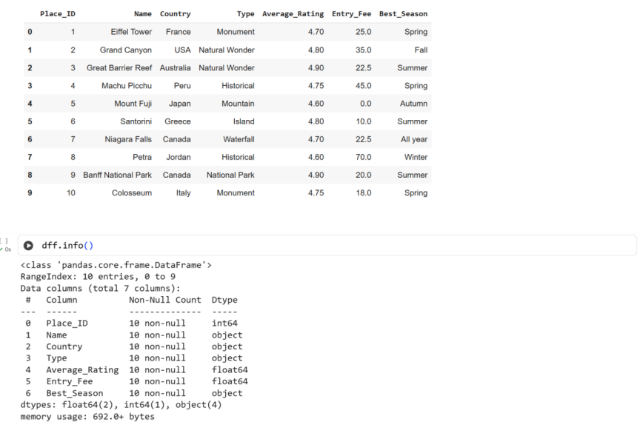
Result:
Thus the python program to create own dataset and change it to csv file is executed and
verified

